Invoice Download:
From Dashboard/Initial page. Click on Account Statement Status
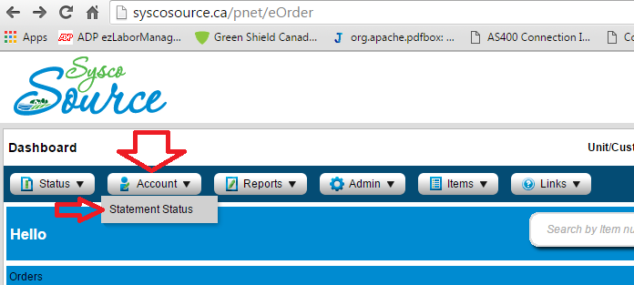
Default page shows open invoices.
To see history invoices, click on Statements Statement History.
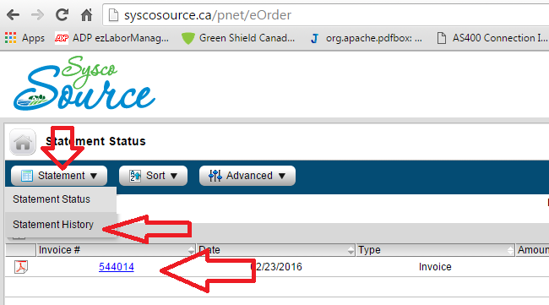

To download the invoice in COSTGUARD format, Click on the Invoice number and open the invoice.
Click on Advanced Export CostGuard. It downloads to your PC download folder.
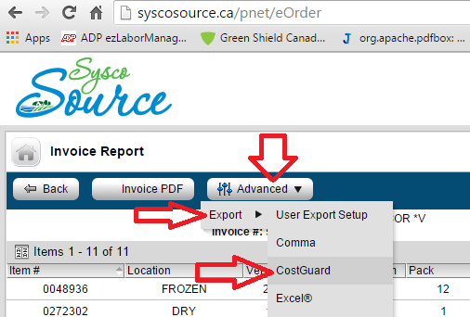

Order Guide:
From Dashboard page, Click on Reports Guides Standard guide.
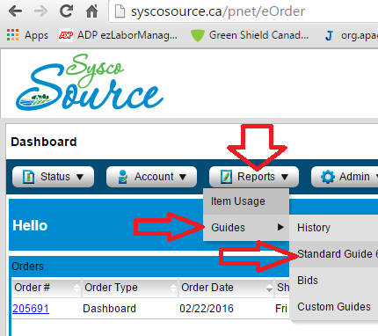
From Standard Guide Report page, Click on the Advanced Export CostGuard – It downloads the guide into your PC.
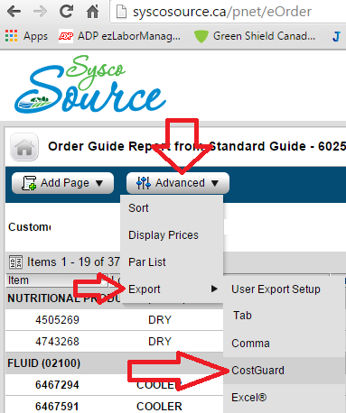

Order/PO Upload:
At the right end of the Dash board page, click on the “New Order”
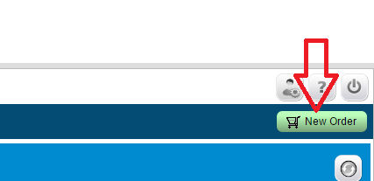

On the Ordering Option popup page,
- Select “From” type Import
- Select “Import” format CostGuard File
- Click “Start Order with above selections” to import the items to SyscoSource Order

