^{Exporting/Importing:}
- Update Items / Pricing in CostGuard
- Path: New Order > From (Order Guide or Custom Guide) > Advanced > Export > Standard Comma
- GFS Connect Export format is (comma) then name the file and save as txt in the appropriate folder
    - Once exported Delete Order from Advanced menu option
- In Costguard > Inventory Mgmt > Vendor Transport Import > format GFS/Canada - Retalix (comma)
    - Vendor Must be created in Costguard first, before importing invoices or order guides.
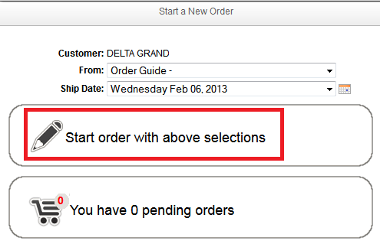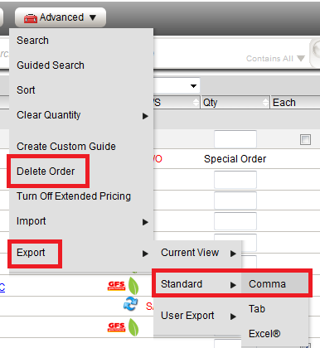

- Import Costguard Order into GFS Connect
- Export Order from Costguard then Import into GFS Connect
- The Export format in Costguard is (IDSpowernet.txt Retalix/ids-PowerNet ASCII)
- GFS Connect Go to > New Order > Import Other File > Browse to find file > File Format csv. Import Order.

^{COSTGUARD} ^{GFS CONNECT}
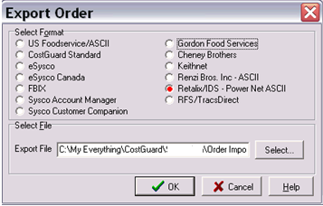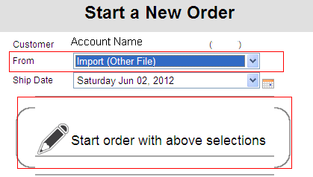

- Import Invoice from GFS Connect into Costguard.
- GFS Connect Path: Account > Statement Status > Click on the Invoice # > Advanced > Export > Comma
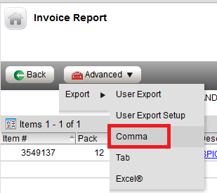

- GFS Connect the Export has to be (comma) then file name > save as txt in the appropriate folder
- Import in Costguard > Inventory Receipts > Gordon Food Service
    - Vendor Must be created in Costguard first, before importing invoices or order guides.
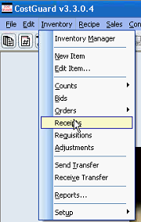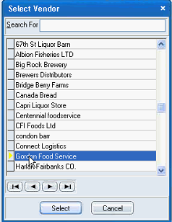

- Import Invoice > GFS/Canada – Retalix(comma)
